EXECUTIVE DIRECTOR
Gray Delany
BOARD OF DIRECTORS
Michael Wood, Chairman,
Wood Entertainment Company
Veronica Birkenstock,
Practical Employee Solutions

Terry Forrester,
Labor Consultants International

James Judkins,
JKJ Workforce Agency

Tim Portland,
Yellowstone Landscape
Mark Thelen,
Landmark Landscapes

Aubrey Vincent,
Lindy’s Seafood
Roger Warren,
Kiawah Island Golf Resort

Libby Whitley,
MAS Labor
Lori Whitten,
Action Visa

July 27th, 2022
FY23 First Half H-2B Cap Analysis
and
Administration Cap Relief Options

The unprecedented labor shortage faced by America’s small and seasonal businesses shows no signs of abating. On July 6th, 2022, USDOL announced that it received 1,360 applications requesting 29,856 positions for a start date of October 1st, 2022. October 1st is when the first 33,000 visa are made available from the fiscal year’s statutory cap of 66,000 visas.
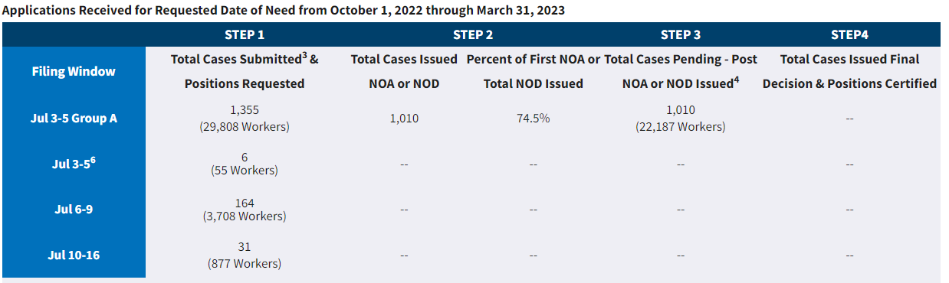

In last year’s FY22 July 3-5 filing period employers requested 21,116 positions. The 29,856 positions requested in FY23 represents a 41% increase over FY22. In FY22 the cap was met on September 30th. Given the robust demand, we expect the cap to be met as soon as early September.

For the last six years, Congress has given the administration the authority to release additional visas. In response to the record H-2B program demand and due to the economic impact on key sectors such as the seafood industry, in FY22 DHS released, for the first time ever, 20,000 additional visas for employers with FY22 first half dates of need.

In last year’s continuing resolution, language was inserted that made it clear that DHS retained its authority to release additional visas. This language enabled DHS to proceed with the first half visa release.

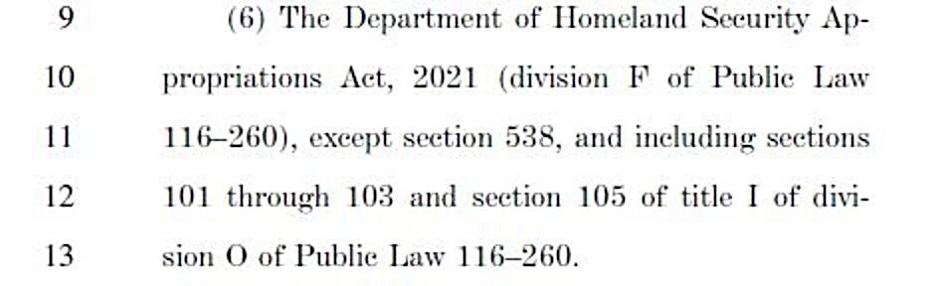

In the FY23 House DHS Appropriations bill, appropriators updated the DHS H-2B discretionary language to remove the need for rulemaking (see highlighted section below).

(a) Notwithstanding the numerical limitation set forth in section 214(g)(1)(B) of the Immigration and Nationality Act (8 U.S.C. 1184(g)(1)(B)), the Secretary of
Homeland Security, after consultation with the Secretary of Labor
, and upon the determination that the needs of American businesses cannot be satisfied in fiscal year 2023 with United States workers who are willing, qualified, and able to perform temporary nonagricultural labor, may increase the total number of aliens who may receive a visa under section 101(a)(15)(H)(ii)(b) of such Act (8 U.S.C. 1101(a)(15)(H)(ii)(b)) in such fiscal year above such limitation by not more than the highest number of H–2B nonimmigrants who participated in the H–2B returning worker program in any fiscal year in which returning workers were exempt from such numerical limitation.

(b) The Secretary of Homeland Security shall issue guidance implementing this section no later than 60 days after enactment.

(c) Notwithstanding section 553 of title 5, United States Code, such guidance may be published on the internet website of the Department of Homeland Security; and shall be effective immediately upon such publication.

Action items needed to alleviate cap crisis faced by employers with first half date of need:

- Option 1: DHS should request the language from the FY23 House DHS Appropriations bill be included in the FY23 CR. The language removes the need for the rulemaking process. The lengthy rulemaking process has led to delays in the visa releases, suppressing demand for the allocation of Northern Triangle workers. For example, the first half release was not published until January 28th. This was after employers had already filed on January 1st and committed to an April 1st date of need.
- Option 2: If option 1 is not obtainable, DHS should work with the appropriators to ensure that its authority to release additional visas remains in the event of the CR. The same language can be used from last year (substituting the dates of course).
The administration has the opportunity to come to the rescue of America’s small and seasonal businesses by making a timely and significant first half visa release. An additional benefit of a substantial release would be to allow employers with historical February and March dates of need to file for those dates. This would reduce the demand on the second half allocation and space out DOL’s workload, preventing the processing delays that occurred last spring.
Sincerely,
Gray Delany, Executive Director
Seasonal Employment Alliance
And
Michael Wood, Chairman
Seasonal Employment Alliance
Owner, Wood Entertainment Company

